Відділ освіти Підволочиської райдержадміністрації
Районний методичний кабінет

Розробка
уроку англійської мови
у 10 класі на тему:

«Наука і технічний прогрес.»

Підготував:
викладач англійської мови
Підволочиської гімназії
імені І. Франка
Кобильняк В.В.

Підволочиськ 2015
Level: Intermediate
Time: 45 minutes
Theme: Science and technological progress. Наука і технічний прогрес.
Aims:
- To develop the pupils’ communicative skills, discussing nowadays and future;
- To train the pupils in using the first conditional;
- To learn how to conduct the argumentive debates.
Teaching aids: Solutions Intermediate 2nd edition student’s book, work book, CD; power point presentation “Conditional 1” triumph board, laptop.
Key vocabulary: research, games console, social-networking, email.

PROCEDURE
- Greetings.
T. Well, pupils, at today’s lesson we’ll talk about nowadays and the future. We’ll try to conduct the argumentive debates and develop our reading skills.
- Warm up.
T. Imagine that it is the year 2080, and you are sitting and talking to your grandchildren. They want to know what life was like at the beginning of the 21st century. What would you tell them about the shopping, travel, entertainment and sport?
Ok, I think you’ll be great grandparents and your grandchildren will be not bored with you.
- Main part.
T. - Look at this picture, please. How do you think, what is it?
- Yes, it’s a time capsule
- What is the point of the time capsule?
P. The point of a time capsule is that it shows people in the future what life was like at the time when the objects were buried.
T. Ok, any other points of view?
P 2. – the customs and traditions, the culture.
T. What kinds of items do you think would be interesting to people in the future?
P 1. The items that would be interesting to future generations might include objects that tell them about everyday life, technology, culture, the price of things and what was happening in the world of that period.
P 2. The items that show the culture of that period.
P 3. Some objects of technology.
P 4. The money and the price of things.
T. – What objects can you see in this capsule?
T. – Look at this exercise:
If you complete these compound nouns, it will help you to identify items of the time capsule.
T. Now, you can answer what items are there in this time capsule?
- How do think would they be interesting to people in the future?
P. – I think yes, because the things change, the shapes of the objects change.
- Grammar practice.
Now it’s the time for grammar. We continue to talk about the present and the future. We often make predictions with the first conditional. Look at this grammar structure:
If + Present Simple, will + do (infinitive)
Will + do (infinitive) If + Present Simple
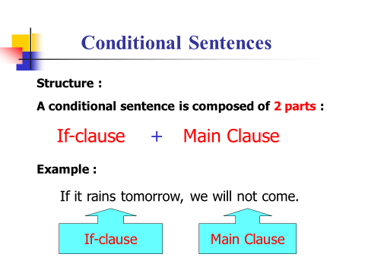
Use the power point presentation

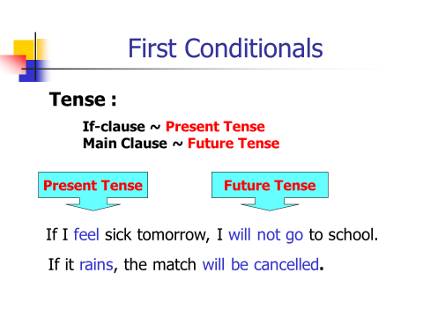
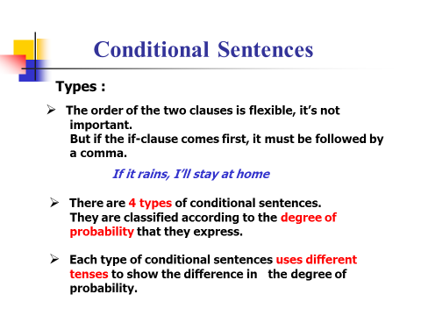

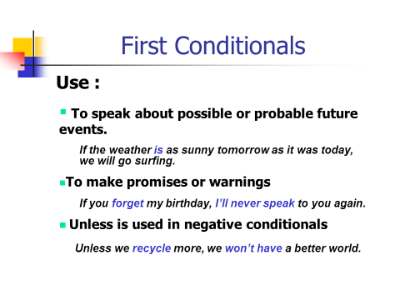
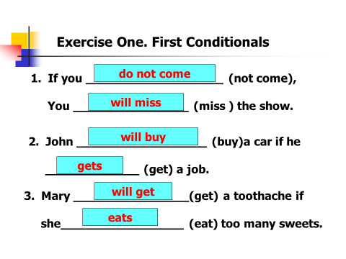
(Ex. 2 pg. 116 / Ex. 7 pg. 45)
- Speaking practice.
We have already revised a lot of material. I think you are ready to the debate. Are you? Our debates we’ll start with a short questionary, after which you can tell me the topic of our debate.
Questionary
- Do you have a computer at home?
- Is there a post office in your town?
- How often do you use a computer?
- Do you use any postal services, if so, which of them?
- How long have you been using the internet?
- Is the post office necessary for you?
- What internet websites do you surf?
- Why is the internet important nowadays?
- Do you write letters to your friends or relatives?
- Have you ever sent parcels?
- What vocabulary can be used working with the internet?
- Can you name any words connected with post offices?
T. – Now, how do you think what is the theme of our debates?
- Yes, you’re right. The topic of the debate is: Post offices should close. In the age of internet, they are no longer necessary.
For organizing this debate we need 3 groups:
Group A – Internet users. They think the internet is more useful than post offices.
Group B – Post offices supporters. Their opinion is “It’s important to keep post offices open.”
Group C – Independent experts. They have to make the conclusion of our debate.
Each group will get some statements, which support your opinion, plus some words and expressions that help you to conduct the debates.
T. – Let’s start our Argumentive Debate: Post offices should close. In the age of internet, they are no longer necessary.
Experts: Before the beginning of our discussion we, as an independent experts, would like to make a short survey and to ask our guests one question: Should the post offices be closed in the age of internet or not? We’d like you to give only the short answers – yes or no. (The question is in Ukrainian) and we’ll collect your answers at the end of the debate.
T. – What group will start? Shall we do it?
1) Presentation of the Internet Users.
2) Group B presentation.
3) The proses of the debate.
Experts make the conclusion of the debates.
- Summary.
To sum up our lesson I’d like to say that you’ve done well. I’m very satisfied with your answers and I hope we have achieved the aims of our lesson.
- Home assignment.
Prepare challenge task on pg. 41 WB.

