Level: elementary

Teacher: Iryna Takhnovska

Theme. My Family.
Objectives: to teach and practice words and expressions used when describing family, to create a poster about his family; to watch the video about the family members and participate in different kinds of activities; to role play dialogues; to develop logical thinking, communicative skills, to enrich pupils’ knowledge on the topic.
Type of lesson: mixed.
Equipment: a notebook, a video “Gogo’s Adventures with English”, series 3:”She is my mother”; pictures of Gogo; pupils’ family photos; rhymes; songs.

Procedure

1. Greeting.
T. - Good morning, children!
P. - Good morning, teacher!
“Hello Song”
T. – How are you?
P. – I’m fine, thank you!

2. Aim.
T. - Today we shall have a very interesting lesson. We'll meet Gogo’s family. Who is Gogo? Yes, he is a little dragon (фото дракончика).
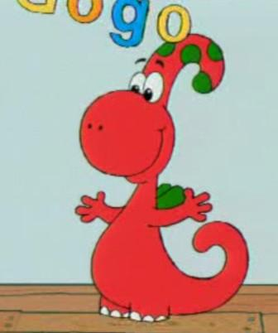

3.Warm-up.
T.: Gogo have got a family: father, mother, sister, brother. Have you got a family?
Rhyme “I have got a father”
I have got a father,
I have got a mother,
I have got a sister,
I have got a brother.

4. Phonetic drills.
T. - Repeat after me:
[ m] Mother, my mother, her mother, his mother. I love my mother.
[ f ] Father, my father, her father, his father. I love my father.

5. Watching the video “Gogo’s Adventures with English”. Series 3: “She is my Mother”.
1) Pre-Watching Activity.
T.: Look around. Who is he? – He is your friend. Who is she? – She is your friend.
2) While-Watching Activity.
T.: Watch and remember Gogo’s family.
3) Post-Watching Activity.
T.: Look at the photo of Gogo’s family. Who is he? Who is she?
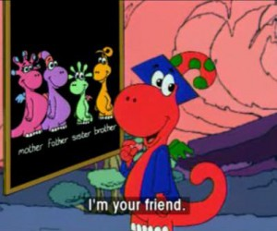

6. Speaking. Describing Family Photo.
T.: Tell about your family in the photo.
P.: He is my father. She is my mother. He is my brother. She is my sister.

7. Making a collage

T. All your families are unique. Let’s make a collage “A Family Album” on a big heart.

8. Summarizing.
1) T.: Let’s finish our lesson with a rhyme:
Father, mother,
Sister, brother,
Hand by hand,
With one another.
2) “Goodbye Song”

