Урок з американської літератури у 11-А класі.

Тема: Romanticism and the American Renaissance 1820-1865.
Ціли уроку:
Практичні: Ознайомити учнів з періодом Романтизму в Америці. Визначити характерні риси періоду. Ознайомити учнів з реаліями того періоду.
Освітні: Поглибити знання учнів з курсу історії та літератури Америки.
Виховні:
– виховання культурного и мовленнєвого спілкування, знання культури та традиції.
Розвиваючі:
– розвиток мовної здогадки, пам’яті;
– розвиток уваги та емоцій.
Загальнонавчальні:
– розширення кругозору;
– формування моральних цінностей.
Обладнання: Підручник American literature: Посібник для старших класів із поглибленим вивченням англійської мови; додатковий матеріал для учнів з навчального посібника М. Геккер, Т.Волосова «Американська література», додатковий ксерокс для учнів, ноутбук з презентацією для учнів.
Хід уроку
Вступ:
T: Glad to see you. Take your seats. We are going to work together during this month. We are to start new theme: “Romanticism and the American Renaissance in 1820-1865”. I hope you know that all important events are reflected in literature that is why it is necessary to find out some peculiar features about this period.
Основна частина уроку:
T: So it is necessary to start with the definition and general movements of Romanticism in Europe. But I would like to ask you: Have you heard anything about Romanticism? Maybe you have read something concerning this period?
P:………………………………..
T: So let’s write down the definition. Romanticism is the theory, practice and style of the romantic art, music and literature of the late 18th and early 19th centuries, usually opposed to classicism. Romanticism characterizes by peculiar attention towards human and peculiar endeavor of national originality.
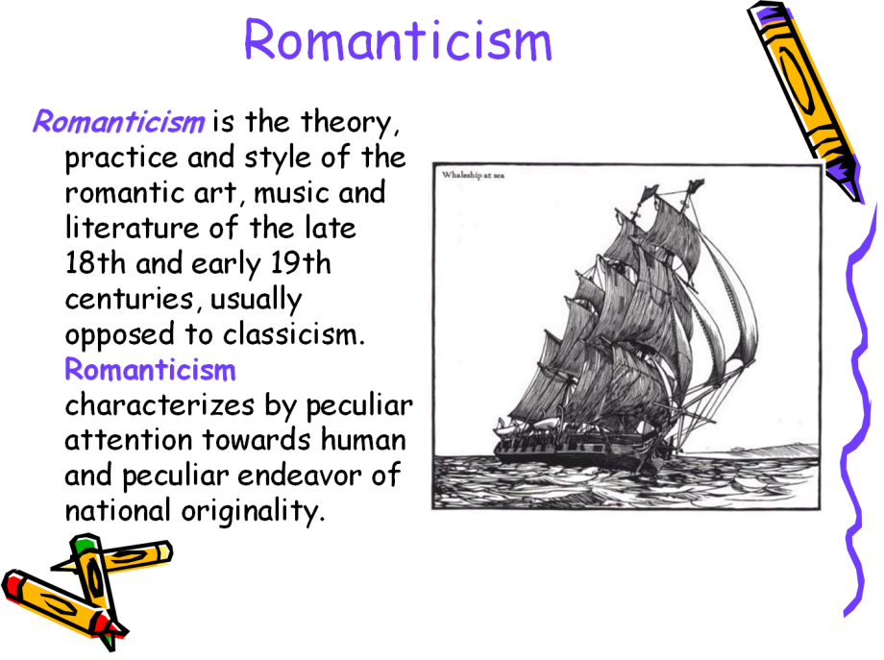(слайд з презентації)
T: How do you think in what way is Romanticism opposed to classicism?
P:………………………………
T: Good, but I think that we should write the definition of classicism. Classicism- is a style based on the study of Greek and Roman models, characterized by emotional restraint and regularity of forms. It is also very important to mention that demanded: an intricate intrigue; a dynamic movement of events and sudden changes in the hero’s life. The romantic poets and writers produced a powerful literature with wide variations. They enriched literary theory developed such genres as the novel(historical, social, fantastic, utopian, intellectual), the romance and the short story.
Now I want you to study the movements of Romanticism, there were six basic movements of Romanticism.
(перегляд презентації)
Movements of Romanticism
I. Early or Universal (XVIII-XIX centuries); Novalis, W. Blake.
Characteristic features:
II. Folk Romanticism (XIX century); W. Scott, Wordsword.
III. Byronic Romanticism(10-30th of XIX century); Byron, Pushkin, Lermontov.
Features: At that time pridominated total denial of existed reality.
There was a forthcoming of a new type hero- rebel-hero.
IV. Fantastically-grotesque (20-60th of XIX century Edgar Allan Poe.
Features: The basic interest was concerning social, philosophical and psychological aspects of life. There came a problem between the outer and the inner world of a human.
V.Walterscottish Romanticism\ Historical (30-70th of XIX century); Walter Scott, F. Cooper.
Features: It was a time of the reproduction historical events. When authors depicted past they were sure that they could find some keynotes for understanding current troubles of their time.
VI. Utopian Romanticism; (30-40th of XIX century).
Features: For that time it was important to idealize the main hero, who always was ready for a self-sacrifice just for the sake of others. There always came an optimistic keynote and of course positivism.
Characteristic features of the works
1.- there was a gap between reality and the ideal[the dream of the poet, writer.
2.- it was important to transfer all our attention to the sphere of subjective-personal, individual.
3.- authors emphasized an eminent interest to the emotional - inner world of the main heroes.
4.- there was always an admiration of smth. fantastic, strange, irrational.
T: Now I want you to summarize everything and we are to discuss everything. So who is going to be the first and characterize one of the movements.
P:……………………………………
P:………………………………………..
T: Now when we have discussed peculiar features of the movements of Romanticism, it is high to study peculiar historical events that had a great impact on the American Romanticism. So let’s write down: 1.The Revolutionary War (1775-1783)- it was the event during which a new state – The USA appeared.
2. The Civil War (1861-1865) – the war between North and South.
Students now you are to read the paragraph, open your books and start reading……….
P:………………………………….
T: We are to write down important points from the paragraph so write down: Monroe Doctrine - was a great document, because it was really very important for American Nation. James Monroe was the 5th president of America, he participated in the Revolutionary War. He was the author of foreign-policy doctrine. Monroe wanted to protect young state interfering of others countries.
And I want you to write down about the Transcendentalists, they were the people who contended an idea that a person could reach moral and spiritual perfection much easier with the help of communication with nature instead of following concrete church dogmas. They believed that human is strong enough to be the master of one’s own life.
Заключна частина:

T: Your home task is Unit 3: learn and speak on the subject.

